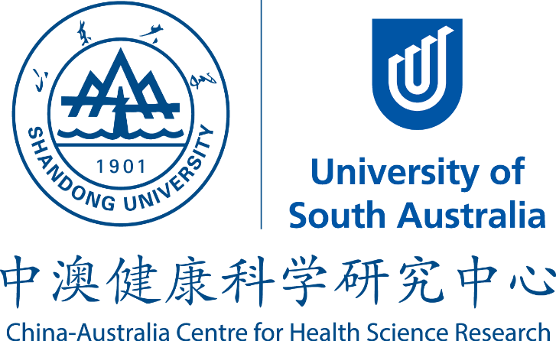

China–Australia Centre for Health Sciences Research (CACHSR)

Terms of Reference for Joint Research Proposals 2015

Closing Date: Oct 16, 2015

China–Australia Centre for Health Sciences Research (CACHSR)

The CACHSR is a collaborative program between the University of South Australia and Shandong University. It aims to promote significant collaboration which will allow the complementary research resources of both universities (UniSA and SDU), and other research bodies, government bodies and business partners to collectively support research in the field of Health Sciences.

Terms of Reference

The CACHSR Call for Research Proposals scheme funds highly innovative, intrinsically collaborative and transformational research that will lead to internationally significant advancement of capabilities and knowledge in the area of Health Sciences.

The CACHSR seed funding scheme is competitive, submission of application does not guarantee approval of funding.

Research Leaders:

Selected research proposals will be supported under the over-arching umbrella of the health sciences theme. Each proposal will have at least one PI from Shandong University and University of South Australia. Research leaders are advised to form research groups (clusters) including research students and early career researchers to identify research proposals.

Other objectives of the CACHSR Call for Proposals scheme include:

- link existing Australian/Chinese research strengths and build critical mass with new capacity for collaborative approaches to address the most challenging and significant research problems in health;
- develop relationships and build new networks to help strengthen research, achieve global competitiveness and gain recognition for UniSA/SDU research;
- provide high-quality postgraduate and post-doctoral training environments for the next generation of researchers;
- offer Australian and Chinese researchers opportunities to work on problems and questions related to health sciences; and
- establish a reputation as a centre of research excellence in health.

Budget:

CACHSR has been established initially for a four year period (2013-2017). Research projects can be funded for maximum of two years, with a limit of up to 10,000 AUD for the UniSA part and up to 50,000 RMB for the SDU component. Applicants can seek contribution from other sources, if available.

Funding commitment:

Senior management from both Universities is committed to support the initiative with an initial seed funding. A large proportion of this fund will be used as seed funding for research collaboration between UniSA and Shandong University.

Seed funding mechanism:

To kick-start research projects, smaller seed funding amounts will be allocated to suitable projects. Participants are encouraged to seek additional funding support from a variety of sources including collaborating organisation(s) and partner organisation(s).

The template for Request for research funding form has to be used for submission; the deadline will be announced in the annual Call for Proposals.

Applications submitted will be assessed by the Selection Panel, which consists of the Centre’s Co-Directors and two additional members from each country.

What’s new in 2015?

The centre has funded 20 projects in 2013 and 2014, which are progressing very well. In 2015, Centre is keen to support projects which can exhibit identifiable links or contribution from profession or industrial partners. Pairs funded in earlier rounds can be funded only in exceptional circumstances, e.g. highly successful in generating research outputs, external funding or creating network. Investigators funded earlier can submit applications in this round with new research partners, however the performance on previously funded projects will be used as a guide in reviewing the new application.

Selection criteria for the proposal:

50% weighting for the research project (significance, originality);
20% for clear indication of the future prospects of the proposal such as external funding opportunities;
30% for investigators’ track record and/or opportunity for career progression and links with industrial partners.

