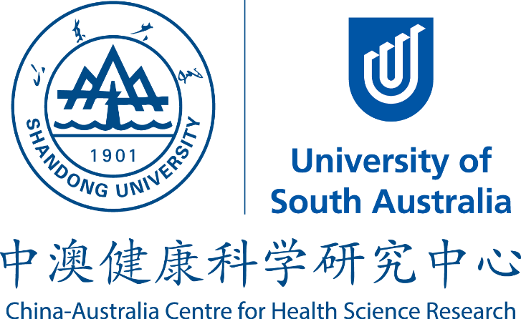

China–Australia Centre for Health Sciences Research (CACHSR)

Application Form for Joint Research Proposals 2015

Closing Date: Oct 16, 2015

Application should include only FOUR pages of this form and TWO page CV of each PI.

- PROJECT TITLE:

- RESEARCH TEAM/PROJECT LEADERS:
(Project Team Leaders to be based at UniSA and SDU, include the name, affiliation and email address)

PI UniSA:

PI SDU:

- OTHER KEY RESEARCHERS / PARTNERS OF MULTIDISCIPLINARY TEAM:
(Names, affiliations, emails and roles. Listed researchers need to be already confirmed as part of the research team. Include information about research students involved)
The Centre encourages the participation of early-career researchers.

Researchers:
UniSA:

SDU:

Industrial Partner(s):

Early Career Researcher involved: ………………………………………………………………………………….

- TEAM FUNDED IN 2013 OR 2014 ROUNDS Yes No

- PROJECT SUMMARY
Provide a two-sentence descriptor (maximum 50 words) of the purpose and expected outcome of the project which is suitable for media or other publicity material. Do not duplicate or simply truncate the 'Summary of Proposal'.

- KEY RESEARCH QUESTIONS TO BE ADDRESSED:

RQ1:

RQ2:

- SUMMARY OF PROPOSED RESEARCH:
Provide a synopsis (maximum one page) describing your proposed research project including brief background, hypothesis, aims, experimental plan and timeline (maximum two years)

- PROJECT OUTCOMES AND BENEFITS:
The Advisory Board of the Centre expects clear achievable outcomes from the seed funding, e.g. a submission of application for other Grant Schemes, impact on policy, or similar, likely to lead to ‘bigger things’.

- POTENTIAL GRANT SCHEME:
Specify which other external grant scheme and funding categories you will use the seed funding for to develop the larger grant application and apply for, with deadline.

- RESOURCES / TOTAL SEED FUNDING REQUESTED:
Please note: maximum 25% of the seed funding requested can be used for travel or equipment. All funds for this Project have to be spent for the purpose for which they are provided.
Seed funding requested: (Maximum of 10,000 AUD for UniSA part and 50,000 CNY for SDU part)

AUS$
RMB

Budget details and justification

- SIGNATURES AND DATE:
We understand that successful applicants must provide a brief report to the Centre within 30 days of project completion, which may be edited and used by the Centre in corporate communications.

……………………………………………………………………………………………………
Project Leader UniSA Date

……………………………………………………………………………………………………
Project Leader SDU Date

Please forward completed forms to both Co-Directors:
Prof Sanjay Garg (sanjay.garg@unisa.edu.au) and Prof Fengshan Wang (fswang@sdu.edu.cn).
Successful applications will be decided by an independent Selection Panel.

